Analyzing the MRO Trace of an LTE Network

In this project, you are asked to process the MRO trace of an LTE network. The MRO report is sent from active UEs in the network to the eNB in a periodical manner, roughly every 5.12 seconds, reporting key information such as the timestamp, UE ID, the signal strength indicator, the time advance (Tadv) etc. The original trace is an xml file which has been converted by me into a simpler format, where each line has numbers representing the following information of a single report:

FD_idx_ID = 1; // UE ID

FD_idx_SECT = 2; // don’t worry about it

FD_idx_TS = 3; // timestamp, measured in miliseconds

FD_idx_PCI = 4; // the ID of the associated eNB

FD_idx_RSRP = 5; // the channel strength indicator from the asscoated eNB

FD_idx_RSRQ = 6; // don’t worry about it

FD_idx_Tadv = 7; // the time advance measurement, where 1 represents 80 m

FD_idx_PHR = 8; // don’t worry about it

FD_idx_UpSINR = 9; // don’t worry about it

FD_idx_SceEuTxRxTD = 10; // don’t worry about it

FD_idx_nPCI = 11; // the ID of a neighboring eNB

FD_idx_nRSRP = 12; // the channel strength indicator from the neighboring eNB

FD_idx_nRSRQ = 13; // don’t worry about it

A UE may send multiple reports for different FD_idx_nPCI at the same time, which will result in multiple lines in the log file. In total, the log file has 6 consecutive hours of data for one base station (with ID 1). You are aksed to process the log file to find the following statistics:

1. The distribution of UEs at various distances to the tower, inferred from the Tadv values. It could happen that a single UE sent reports at more than one location; in such cases, each location should be counted once. It could happen that a UE sent many reports at one location which should still be counted just once.The distribution should be plotted in a graph.

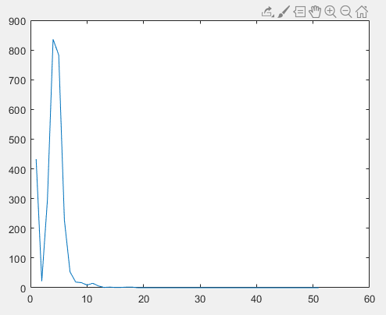

1. The CDF plots of RSRP for a given Tadv value. It could happen that a UE sent many reports at one location, in such cases, the RSRP should be the averge in all such reports. Ignore reports with RSRP being 0.

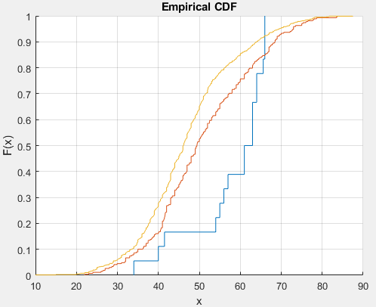

Tadv = 1, 2, 3

1. The network activity, which is the number of connected UEs at any given second in the trace. The CDF should be plotted in a graph.

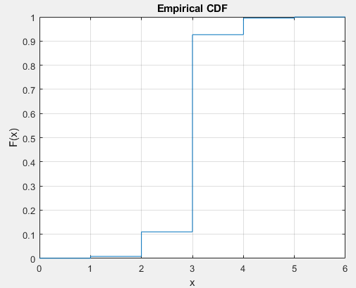

The test data, LTE_TESTDATA_1, can be found on Canvas in Files.